**Effect of Swelling on Multiple Energy Transfer in Conjugated Polymer Nanoparticles**

Louis C. Groff, Yifei Jiang, Xiaoli Wang, and Jason D. McNeill

**KEYWORDS**

Diffusion, Exciton Transport, Modeling, Decay Kinetics, Anisotropy

**ABSTRACT**

Many key processes in conjugated polymers are strongly influenced by multiple energy transfer (i.e., exciton diffusion). We investigated the effect of solvent-induced swelling on the kinetics of multiple energy transfer in nanoparticles of the conjugated polymers PFBT and MEH-PPV. Multiple energy transfer between equivalent chromophores results in loss of fluorescence polarization, which can be observed in the fluorescence anisotropy decay kinetics. Additionally, multiple energy transfer affects the rate of quenching by defects. We found that the rate of energy transfer between chromophores is highly sensitive to solvent effects, occurring at a rate of 1.1109 s-1, and 3.3109 s-1 for PFBT and MEH-PPV dissolved in THF, respectively, and at rates 10-60 times higher in both moderately swelled and aqueous nanoparticle suspensions. A discrete cubic lattice model incorporating distance-dependent multiple energy transfer and quenching by defects was employed to elucidate the relationships between solvent-induced swelling, fluorescence quantum yield, and decay kinetics. The simulation results show good agreement with experimental results at low to moderate THF concentrations. The results support quenching by defects or polarons, amplified by multiple energy transfer, as a likely explanation for the typically low fluorescence quantum yield of conjugated polymer particles as compared to the free polymer in solution as well as similar effects observed in thin films.



**INTRODUCTION**

Conjugated polymers (CPs) are a versatile class of semiconducting luminescent materials, used as active materials in organic photovoltaics and light-emitting diodes.1,2 Conjugated polymer nanoparticles (CPNs) have extraordinary figures of merit, such as high fluorescence quantum yield, high extinction coefficients, exceptional photostability, and excellent spectral overlap with red-emitting fluorescent dyes and polymers, making them well-suited for fluorescence based imaging applications.{Wu, 2008 #51;Wang, 2013 #61;Wu, 2008 #49;Tian, 2013 #62;Wu, 2006 #48} To tune CPN properties for various applications, we seek to better understand the species and processes that dictate their properties, and how they are modulated by polymer conformation and processing conditions.{Schaller, 2002 #98;Wu, 2008 #99} In particular, aggregates, chemical defects, and excess charges (i.e. photogenerated hole polarons) cause significant changes in the emission wavelength, fluorescence lifetime, and fluorescence quantum yield of conjugated polymer films and particles.{Jelly, 1936 #21;Hayer, 2012 #18;McNeill, 2002 #30;Hintschich, 2003 #19} In addition, energy homo-transfer between conjugated polymer chromophores (i.e., exciton diffusion)[ref] can greatly amplify quenching by defects and aggregates through multiple energy transfer.[ref Tian review] Recently, we showed that multiple energy transfer in CPNs gives rise to characteristic complex fluorescence kinetics.{Groff, 2013 #60}

Here, we investigate the effects of solvent-induced swelling on the rate of multiple energy transfer in CPNs, as well as the reversibility of quenching by defects via swelling, using a combination of steady-state and time-resolved fluorescence spectroscopy, in conjunction with a lattice model that accounts for the effects of swelling and quenching by defects. We previously employed a similar approach to determine the length scale of exciton diffusion in dye-doped CPNs.{Groff, 2013 #60} Particle swelling increases the inter-chromophore distance, causing a reduction in the rate of multiple energy transfer and thus a reduction in the quenching efficiency and an increase in the excited state lifetime. By comparing picosecond fluorescence anisotropy decay results to a multiple energy transfer model, we obtain an approximate picture of the characteristic length scale and time scale of homo-transfer. The quality of fit over a broad range of swelling supports the proposed multiple energy transfer picture. The comparison of MEH-PPV and PFBT results suggests that higher rates of homo-transfer, which is sometimes desired (e.g., to improve exciton transport in photovoltaics, or for CPN sensors) comes at the price of reduced fluorescence quantum yield. This provides a possible explanation for the large reduction in fluorescence quantum yield observed for some conjugated polymer films and particles as compared to the free polymer.

**EXPERIMENTAL METHODS**

**Materials.** The copolymer poly[(9,9-dioctylfluorenyl-2,7-diyl)-*co*-(1,4-benzo-{2,1',3}-thiadiazole)] (PFBT, MW 10,000, polydispersity 1.7), and the poly(phenylene vinylene) derivative poly[2-methoxy-5-(2-ethylhexyloxy)-1,4-phenylenevinylene] (MEH-PPV, MW 200,000, polydispersity, 4.0) were purchased from ADS Dyes, Inc. (Quebec, Canada). The fluorescent dye fluorescein was purchased from Life Technologies (Invitrogen, Eugene, OR). The fluorescent dye Lucifer Yellow CH dipotassium salt (LY, 1 mg/mL in water), solvent tetrahydrofuran (THF, anhydrous, inhibitor-free, 99.9%) and sodium hydroxide (SigmaUltra, minimum 98%) were purchased from Sigma-Aldrich (Milwaukee, WI). All materials were used as provided without further purification.

**Nanoparticle Preparation.** The preparation of fluorescent nanoparticles was performed via a previously described nano-precipitation method.{Szymanski, 2005 #42} The conjugated polymers PFBT and MEH-PPV were dissolved in THF by gentle agitation and prepared at a concentration of 1000 ppm. An aliquot of each stock solution was used to prepare precursor solutions at 20 ppm. A 2 mL quantity of a given precursor solution was rapidly added into 8 mL of deionized water under bath sonication at a frequency of 40 kHz and room temperature. Removal of THF was accomplished by the following procedure. Nanoparticle suspensions were placed in a vacuum oven under nitrogen flow for 8 hours at room temperature in order to remove enough THF to prevent bumping during the subsequent vacuum evaporation step. Nitrogen flow was ceased and samples were evaporated under vacuum in a vacuum oven at room temperature using a two-stage rotary vane pump with a base pressure of ~10 torr. The samples were heated at ~40 °C for 6-7 hours to remove most of the remaining THF. The total volume of liquid was reduced by typically 60% during the vacuum evaporation process. The total loss in solution volume was determined to be sufficient via Raoult’s Law calculations, which yield that <1% THF remains in solution at ~40% volume loss. No residual THF odor was detected in the aqueous samples. Also, at this point, further evaporation yielded no change in the fluorescence spectrum or quantum yield. We validated this process further by assessing the batch-to-batch reproducibility of the fluorescence spectra, and fluorescence quantum yield of the aqueous nanoparticle samples. Four batches of nanoparticles were prepared using each polymer. The nanoparticle fluorescence spectra were identical in shape and peak emission wavelength for both polymers. The fluorescence quantum yield varied between 4%-6% for PFBT CPNs, and remained constant at ~1% for MEH-PPV CPNs. The aqueous samples were vacuum filtered through a glass fiber prefilter to remove larger aggregates and a 0.1 µm PVDF membrane filter (Millipore). The resulting suspensions are clear (not turbid) and stable for months with no visible signs of aggregation.

**Characterization Methods.** UV-Vis absorption spectra were acquired using a Shimadzu UV2101PC scanning spectrophotometer with 1 cm quartz cuvettes. Fluorescence spectra and fluorescence quantum yield were measured with a commercial fluorimeter (Quantamaster, Photon Technology International) using 1 cm quartz cuvettes.

Picosecond fluorescence lifetimes and fluorescence anisotropy decay (FAD) were measured under nitrogen using a home-built setup for time-correlated single photon counting (TCSPC) spectroscopy operating in reverse mode. Frequency doubled pulses (420 nm) from a passively mode-locked Ti:Sapphire laser (Coherent Mira 900, 840 nm pulses, ~150 fs pulsewidth) were used as the excitation source for the nanoparticle samples. Fluorescence was collected perpendicular to the excitation source and passed through a 460 nm long pass filter, and a calcite Glan-Taylor polarizer (Thorlabs, GT10-A) oriented either parallel (0°), perpendicular (90°), or at magic angle (55°) to the vertically polarized excitation pulses. All three polarization angles were utilized for anisotropy decay measurements, and magic angle polarizer orientation was adopted for excited state population decay measurements. The output of a single photon avalanche photodiode (APD, id Quantique, id100-50) was used as the start timing pulse for a time-to-amplitude converter (TAC, Canberra Model 2145), and the output of a fast PIN diode (Thorlabs, DET210) was used as the stop pulse, in a standard reverse-mode configuration.{Schaffer, 1999 #88;Cross, 1984 #87} The excitation power was attenuated (between ~300 µW and 1 mW, typ.) to maintain a count rate of ~400 kHz as measured at the APD. The analog TAC output was digitized using a multi-channel analyzer (FastComTec, MCA-3A). Before and after each measurement an instrument response function (IRF) was measured using scattered excitation light from a dilute suspension of polystyrene microspheres. The width of the IRF was determined to be ~70 ps (fwhm). Typical peak signal-to-noise ratios (SNR) for each run were between 200:1 (80%-100% THF samples) and 500:1 (IRF and low-mid % THF samples). The reported information was collated from a total of two samples per concentration of THF, and 3-5 runs per sample. Intensity decays were collected for 5-20 minutes each to obtain the above mentioned SNR values, depending on the lifetime of the sample.

**Swelling Procedure.** In addition to nanoparticles in water and polymer in THF, swelled nanoparticle samples were prepared by diluting an aliquot of concentrated nanoparticle suspension with the appropriate volume of water, followed by slowly adding THF to produce 3 mL of suspension with volume ratios of THF/water between 0.2 and 0.95. Each sample was gently agitated to ensure solution homogeneity. The sample absorbance was kept at or under ~0.05 (~0.02 for 95% THF). Samples were purged with nitrogen for ~2 minutes, in order to limit loss of THF.

**RESULTS/DISCUSSION**

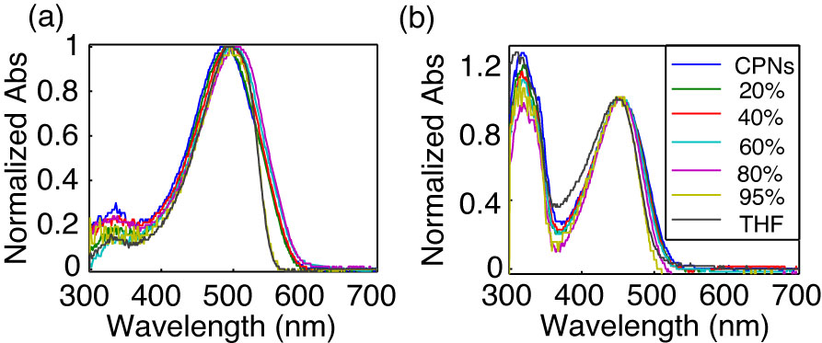

**Fig. 1.** Normalized absorption spectra of (a) MEH-PPV and (b) PFBT at varying volume % THF.

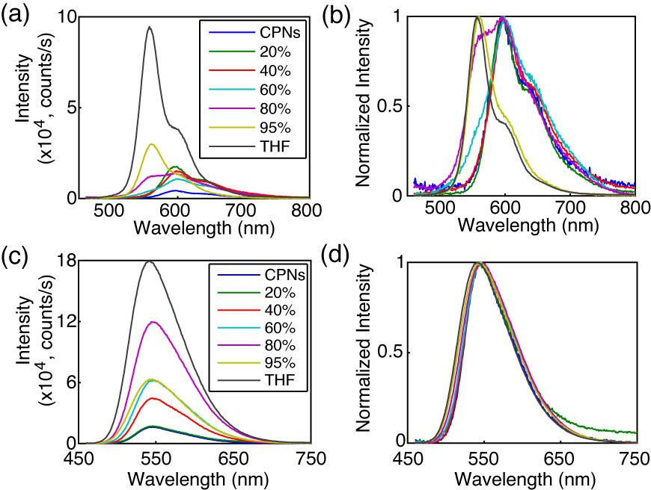

**Fig. 2.** (a,c) Absolute and (b,d) normalized emission spectra of MEH-PPV (top) and PFBT (bottom) at varying volume % THF.

**Effect of solvent composition on UV-vis and fluorescence.** The UV-Vis and fluorescence spectra of PFBT and MEH-PPV as a function of solvent composition are given in Figs. 1 and 2. The absorption spectra of PFBT maintain a similar shape with increasing THF, with a ~5 nm total blue shift, and slight broadening of the sample spectrum in 100% THF. The emission spectra show a monotonic increase in fluorescence intensity with increasing THF, and the spectra also exhibit a blue shift ~5 nm with increasing THF. The absorption spectra of MEH-PPV maintain a similar shape as THF concentration is increased, though the 95%-100% THF spectra are narrower than the spectra of the other samples. The absorption peak of MEH-PPV red shifts a total of ~15 nm from 0%-80% THF, and then blue shifts ~7 nm for the 95%-100% THF samples. The emission peak blue shifts a total of ~40 nm as THF composition is increased, and it appears that from ~40% THF to 80% THF there are possibly two phases present in solution based on the increase in intensity of the ~560 nm shoulder on the spectrum, and the reduction in intensity of the ~600 nm shoulder of the spectrum as % THF increases. An approximate isosbestic point can be seen at ~580 nm over the concentration range of ~60%-80% THF.

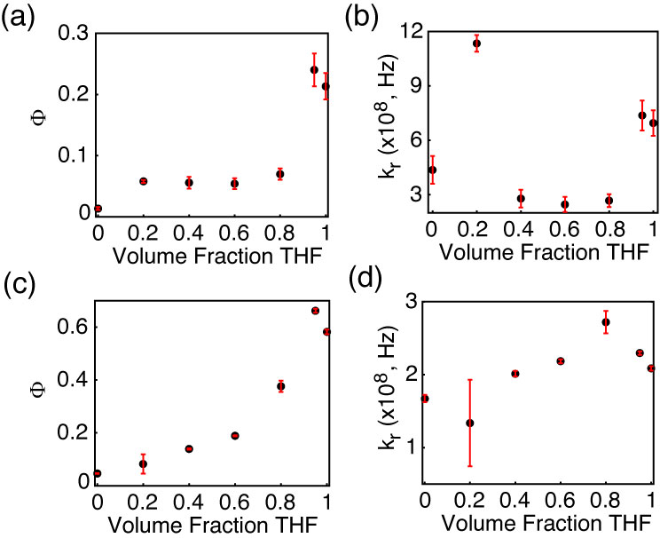

**Fig. 3.** (a,c) Fluorescence quantum yield and (b,d) radiative rate vs. THF volume fraction for MEH-PPV (top) and PFBT (bottom).

The fluorescence quantum yields ( and calculated radiative rates, where the radiative rate is given by are given in Fig. 3. The quantum yield of PFBT increases monotonically with increasing THF. However, MEH-PPV shows an initial intensity increase from 0%-20% THF, followed by the quantum yield staying relatively consistent from 20% to 80% THF, then increasing at higher %THF. The ~12% difference in quantum yield between the CPN samples in 95% THF and the dissolved polymers in THF is ascribed to the uncertainty in the absorbance at such low concentrations of PFBT and MEH-PPV. The quantum yield remains relatively constant for MEH-PPV at moderate THF concentrations and can be ascribed to increased separation of weakly fluorescent, red-shifted CP aggregates from 20% to 80% THF.[I’m not quite sure what you are saying here] The radiative rate varies over a factor of ~2 for PFBT and a factor of ~4 for MEH-PPV over the range of THF concentration.[there is a lot of scatter it seems. Do you think perhaps the uncertainty is too high to see a trend? Maybe we need to cut the radiative rate plot? In any case, the radiative rate discussion belongs later, after the initial discussion of lifetimes and KWW fitting, since it depends on that.]



It is possible that the results outlined in Figs. 2 and 3 indicate that the coupling between transition dipoles is somewhat stronger for MEH-PPV compared to PFBT. This is supported by the steady-state spectra, which exhibit a pronounced red-shift (in both absorption and emission) for MEH-PPV, while PFBT exhibits much smaller shifts. It is possible that the lesser red shift in the absorption spectra of MEH-PPV can be explained by a smaller number of chromophores in MEH-PPV having their transition dipoles strongly coupled compared to the total number of chromophores per CPN, i.e., there is a small fraction of J-aggregate species. This is consistent with the two-state picture of Barbara, et al., used to discuss the bimodal emission properties in [single molecule spectra of?] both PFBT and MEH-PPV. In this picture, there is a minority aggregate state that exhibits weak, red-shifted emission, and acts as an energy acceptor to the free polymer.{Grey, 2006 #102;Lee, 2006 #105;Kim, 2006 #108}[probably want to cite the earlier papers where this model first appears] In the case of swelling, it is plausible that either the swelling disrupts aggregate formation, or that it reduces the rate of energy transfer to aggregate species, or both.

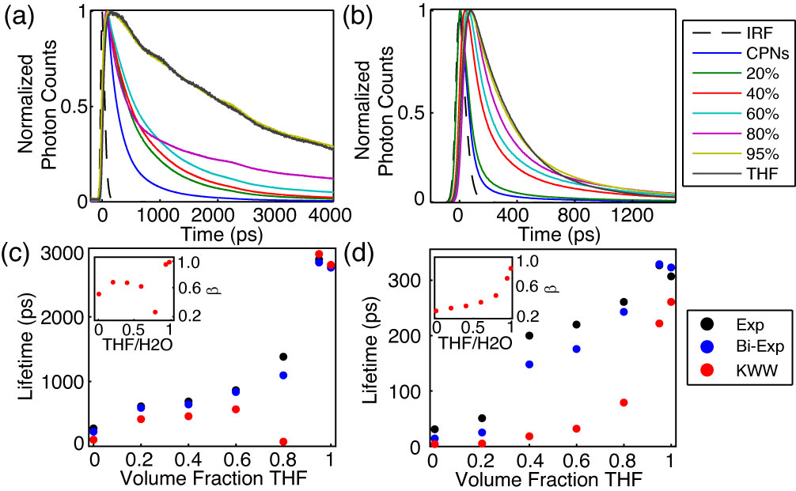

**Fig. 4.** (a,b) Normalized fluorescence intensity decays, and (c,d) lifetimes resulting from single exponential, bi-exponential weighted average, and KWW trial functions with stretch parameter ** insets) versus THF volume fraction for PFBT and MEH-PPV, respectively.

**Table 1.** Summary of results of bi-exponential least-squares fitting to time-resolved fluorescence of MEH-PPV and PFBT CPNs, including weighted amplitudes (***A1***, ***A2***) and individual exponential time constants (***1*********).

|  |  |  |  |  |  |  |  |  |
| --- | --- | --- | --- | --- | --- | --- | --- | --- |
| **Volume Fraction THF** | **MEH-PPV** | | | | **PFBT** | | | |
| ***A1*** | ***1* (ps)** | ***A2*** | ***2* (ps)** | ***A1*** | ***1* (ps)** | ***A2*** | ***2* (ps)** |
| **0** | 0.96 | 9 | 0.04 | 150 | 0.59 | 88 | 0.41 | 420 |
| **0.20** | 0.93 | 14 | 0.07 | 180 | 0.51 | 260 | 0.49 | 940 |
| **0.40** | 0.73 | 56 | 0.27 | 400 | 0.51 | 280 | 0.49 | 1000 |
| **0.60** | 0.75 | 74 | 0.25 | 480 | 0.55 | 360 | 0.45 | 1400 |
| **0.80** | 0.75 | 120 | 0.25 | 620 | 0.65 | 230 | 0.35 | 2700 |
| **0.95** | 0.80 | 220 | 0.20 | 760 | 0.02 | 230 | 0.98 | 2900 |
| **1** | 0.95 | 270 | 0.05 | 1300 | 0.01 | 270 | 0.99 | 2800 |

**Picosecond Time-Resolved Fluorescence Spectroscopy.** TCSPC obtained at magic angle to the excitation source was employed to measure the excited state decay kinetics of both CPN systems over the range of solvent composition. The trial functions employed during iterative reconvolution fitting analysis were single exponential, bi-exponential, and the Kolrausch-Williams-Watts (KWW) function or stretched exponential, given by , where ** is the stretch parameter. Values for ** are typically between ~0.3 and 1, where lower values correspond to a broader distribution of lifetimes, and **   corresponds to a single exponential lifetime.{Chen, 2003 #8} The fits to all three trial functions converged for all samples. With exception of PFBT in THF which was fit best by a single exponential, the remaining intensity decays fit best to bi-exponential and KWW trial functions, indicating heterogeneous kinetics.[It’s not so much that they fit best to KWW/bi-exp, it’s that the fit to single exponential was very poor and showed systematic deviation consistent with bi-exponential or multi-exponential dynamics] The representative intensity decays for each sample, along with the respective time constants and **versus THF volume fractionare given in Fig. 4. The lifetimes for both systems follow a monotonically increasing trend as THF concentration increases. The lifetimes of the CPN samples in water are shorter than previously reported (~275 ps versus ~700 ps previously for PFBT) but can be ascribed to a more complete THF removal process, as evidenced by [maybe something more like “this explanation is also consistent with”] the ~~accompanying~~ reduced quantum yield ( = 0.04 versus  = 0.14 previously for PFBT CPNs). ** increases for both systems as the fraction of THF increases, beginning at ~0.3 for MEH-PPV in water and increasing monotonically to ~0.8 for MEH-PPV in THF, indicating [an overall decrease in lifetime heterogeneity, though even in good solvent there is some heterogeneity...] that even in good solvent MEH-PPV exhibits complex decay kinetics. Similarly, ** for PFBT increases monotonically from ~0.6 for CPNs in water to unity in THF. A substantial decrease in* * is observed for PFBT from ~0.7 at 60% THF to ~0.3 at 80% THF, and is indicative of a dramatic increase in the distribution of exciton lifetimes [we might need another sentence or so to unpack this, and/or hint about the possible cause, and/or at least state that this behavior does not follow the overall trend of increasing beta as %THF increases]. The trends in ** [awk phrasing] are hypothesized to be due to the reduction of the rates of multiple energy transfer to the distribution of quenchers, which result from increases in equilibrium chromophore spacing as THF concentration increases.[try rearranging or rephrasing previous sentence] This picture is supported by prior results of dye-doped CPNs, which indicated a reduction in ** as additional quenchers (dyes) were introduced.{Groff, 2013 #60} The net effect [ambiguous phrasing. try to think of something better] is that on average, [is “on average” needed?] an exciton is less likely to fall within the quenching volume of a quencher, which [I believe this is 3 sentences in a row with “which” as the fulcrum. Try to vary sentence structure more.] contributes [“contributes” is too vague to be useful. “causes” would be better(?)] to the increases in **. ~~Additionally, it was found in previous work on dye-doped CPNs that~~ *~~~~* ~~is also roughly proportional to the ratio of~~ *~~L~~~~D~~*~~/~~*~~R~~*~~0~~~~,{Groff, 2013 #60} where~~ *~~L~~~~D~~* ~~is the exciton diffusion length, and~~ *~~R~~*~~0~~ ~~corresponds to the Förster radius of a given quencher.~~[I believe we discussed this, but now that I think of it, this thinking isn’t so relevant to the current case, so let’s skip it, in favor of the hopping distance discussion in the modeling later in the paper.] ~~Given that~~ *~~R~~*~~0~~ ~~is assumed to be fixed in this system, an increase in~~ *~~L~~~~D~~* ~~results in an increase in~~ *~~~~*~~, since an increase in~~ *~~L~~~~D~~* ~~increases the probability of a given exciton successfully escaping the Förster radius of a quencher. It was also found that increases in~~ *~~L~~~~D~~* ~~result in increased quenching efficiency, which contrasts what is observed for this system.{Groff, 2013 #60} This is accounted for by the increases in mean inter-chromophore spacing resulting from swelling, which further reduce the probability of a given exciton falling within the quenching volume of a quencher.~~ The results of the fitting analysis [too vague] are discussed in greater detail below.



A summary of the bi-exponential least-squares fitting results is given in Table 1. For MEH-PPV, the long time constant increases monotonically with increasing THF fraction, and the weighted amplitudes do not change appreciably except for MEH-PPV in 100% THF where the lifetime is nearly single exponential in 1.[lifetimes are not single exponential. also not sure what you mean by “in tau1” either.] In contrast, the time constants remain approximately the same for PFBT between 80-100%, and the weighted amplitude corresponding to the long time constant increases from 80-100% THF. Thus, the lifetime results perhaps suggest a two state-like system, in which CPNs[probably not CPNs--more like “aggregates”] and free polymer [single/isolated polymer chains?] coexist in equilibrium, within a narrow range of THF concentrations.[In addition, does the anomalously low beta at ~70%THF for PFBT also suggest that this is happening in that case as well?] A more detailed discussion of this picture will be covered in a later section.

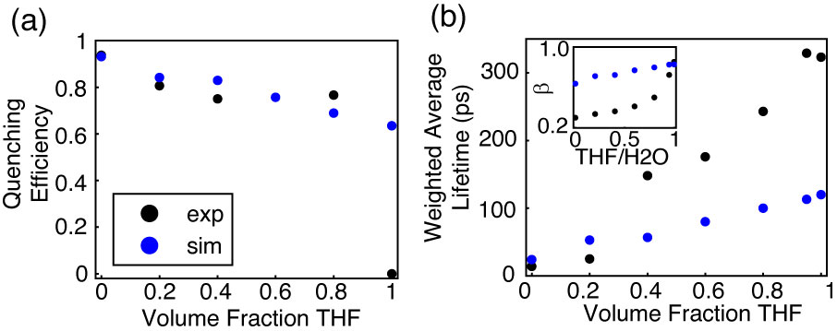

**Fig. 5.** Comparison of simulated (blue) and experimental (black) (a) quenching efficiency, (b) average lifetime, and (inset) KWW stretch parameter *ß* versus THF volume fraction for MEH-PPV.

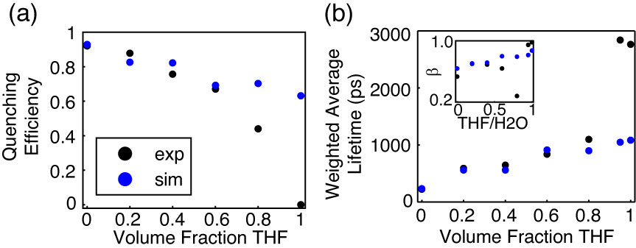

**Fig. 6.** Comparison of simulated (blue) and experimental (black) (a) quenching efficiency, (b) average lifetime, and (inset) KWW stretch parameter *ß* versus THF volume fraction for PFBT.

**Lattice Swelling Model.** Exciton transport in conjugated polymers occurs between chromophores and/or quenchers [somewhat awkward/ambiguous phrasing could be interpreted as saying ET occurs between quenchers. maybe starting from something like “in a dense, multichromophoric system, (incoherent) exciton transport can be described as a series of energy transfer steps to roughly equivalent neighboring chromophores, terminated by a quencher, or radiative or non-radiative relaxation to the ground electronic state”](e.g. nonfluorescent chemical defects or redshifted, weakly fluorescent aggregates) via FRET-mediated multiple energy transfer,[somewhat redundant. and the precise mechanism of ET (e.g., R^-6 dependence) is not important yet in the discussion.] the rate of which depends on the equilibrium interchromophore spacing, which is determined by the amount of swelling in the CPNs (i.e. by the solvent composition). We hypothesize that the multiple energy transfer rate is amplified [?] at low THF concentrations due [to?] increased chromophore density, which provides an explanation for [odd phrasing] the increased quenching and faster decay kinetics in aqueous CPN suspensions compared to the polymers in good solvent. Therefore, we have employed a discrete lattice model [approach?] using a numerical random walk algorithm in order to simulate [model?] the effect of solvent-induced swelling on exciton quenching and decay kinetics. This approach [not exactly this approach] was previously utilized to model exciton diffusion and energy transfer in dye-doped nanoparticles on a discrete cubic lattice.{Wu, 2008 #49} A related approach was employed to model fluorescence centroid fluctuations due to polaron motion on single CPNs.{Yu, 2012 #58} Here, we represent the particle as a cubic lattice. Each lattice point represents one chromophore, with lattice spacing (*x*) determined by the cube root of the volume of one chromophore, assumed to be comprised of two monomer units. Excitons undergo energy transfer between nearest neighbor chromophores, and the energy transfer rate is set to reproduce the observed exciton diffusion length from previous work of *LD* = 12 nm, which is assumed for both polymers.{Groff, 2013 #60} The exciton energy transfer probability for a random walk in the absence of swelling is given by, where *t* is the time step, and *D* is the exciton diffusion constant given by , where is the lifetime of the polymer in the absence of quenchers.



In order to account for solvent-induced swelling, we assume that swelling occurs in a similar fashion to other structurally similar polymers such as polystyrene (PS). As such, increases in the lattice spacing were calculated using particle sizing results obtained by Carson, et al. via optical microscopy on PS beads swelled with THF.{Lee, 2011 #59} A swelling factor, which accounts for increases in nanoparticle size as THF concentration increases, is given by, where *d* and *x* are the swelled and unswelled lattice spacings, respectively. The unswelled lattice spacing is calculated by taking the cube root of the approximate volume of one chromophore, which results in a spacing of 1.2 nm for PFBT, and 0.9 nm for MEH-PPV. The model quenching efficiency and ** are relatively insensitive to the initial chromophore size (0.8 nm versus 1.5 nm, holding all other parameters constant), both with a ~3% difference [awkward. are both results different from some other result by 3%, or is there a difference of about 3% between, e.g., time constants, beta values, obtained with the two different spacings. Also, I’m not sure this is an important calculation--we should adjust ET rate to reproduce Ld as stated below]. The lifetime results yield the largest percent difference at ~20%. These differences are dealt with by scaling the energy transfer rate to reproduce *LD*.[see above] The increase in the interchromophore distance due to swelling is calculated by scaling the interchromophore spacing to match the PS/THF swelling results. Based on the well-known result that transition dipole coupling strength in excitonic systems is proportional to the inter-chromophore distance raised to a power -*k*, which is a constant typically between 2-4, assumed to be 2 for these (or similar) polymers, the multiple energy transfer probability was reduced by an adjusted swelling factor , given by , yielding .{Emelianova, 2010 #14} The time step size was adjusted so that prior to increasing the interchromophore spacing, the energy transfer probability was between 1-2%. An integer number of quenchers are placed randomly on the lattice, each with an assumed quenching radius of 4 nm,[I forget--is this a FRET 1/r^6 distance?] similar to that of a perylene red dye molecule.[need citation] The mean number of quenchers per nanoparticle is determined by adding quenchers until the simulated exciton lifetime approximately reproduces the lifetime of CPNs in water. The number of quenchers for each polymer was determined to be 9 for PFBT, and 10 for MEH-PPV. The greater number of quenchers per CPN than those previously reported for dye-doped PFBT CPNs (2.2 per CPN) can be ascribed to several differences, including the use of a discrete lattice model with fixed step sizes as opposed to a continuum model with random step sizes, and a larger particle (10 [x10x10?] nm cube) was assumed in this model. In addition, the Poisson distribution of quenchers has not been accounted for this model, which results in somewhat higher values for ** than previously reported. The exclusion of Poisson statistical effects on the system is due to the quality of fit of the model results to the experimental results in its absence (discussed below), and has been accounted for in our previous work on dye-doped PFBT CPNs.{Groff, 2013 #60}



At low to moderate THF concentrations, the model results fit well [careful about using “fit”, see explanation below] to experimental intensity decay kinetics and quenching efficiency, the latter given by , where *s* and *poly* are the fluorescence quantum yields of the sample and the polymer in THF, respectively. The simulated quenching efficiency matches the experiment well up to 60% THF for PFBT, and up to 80% THF for MEH-PPV. The fitting results to the simulated intensity decays [awk. Also, “fit” usually implies there was some sort of least-squares minimization to determine model parameters.] match experimental TCSPC fitting results well up to 20% THF for MEH-PPV and up to 80% THF for PFBT. With exception of CPNs in 80% THF,* * is reproduced relatively well for PFBT. However, ** is not reproduced very well for MEH-PPV, except for MEH-PPV in THF. The observed divergence between simulation and experiment outside of the above mentioned solvent compositions corresponds to the regions of moderate THF composition where it is speculated that the polymer is in two conformational states, [try to improve phrasing. conformational states is used more for protein folding] particularly 40%-80% THF for MEH-PPV and 80% THF for PFBT. The poor agreement with experimental ** values for MEH-PPV is likely because effects [awk] from correlated chromophore orientations, and the Poisson distribution of quenchers were not accounted for in this model.



In this and previous work, it has been the aim to identify the causes of the reduced lifetime and ** between polymer in good solvent and nanoparticles in water.{Groff, 2013 #60} [awk/ambig] It has been hypothesized that the principal cause of the reduction in decay parameters for CPNs in water relative to polymer in good solvent is due to quenching by chemical defects or photogenerated hole polarons. With the assumption that multiple energy transfer is a FRET-mediated process, it follows that the energy transfer efficiency to defect sites would depend upon the number of nearest neighbor chromophores, which is proportional to the dimensionality of the system. As an alternate perspective to the above lattice model calculations, the effect of dimensionality on quenching efficiency was investigated for PFBT, by determining how quenching efficiency differs in ~~an ensemble of~~ isolated, one-dimensional chains of PFBT versus a 3D spherical particle.

The information for a spherical particle is taken from the above experimental and simulated data for PFBT, in which the particle is assumed to be 10 nm in diameter, with quenching efficiency ~92%. The quenching radius *Rq* is taken from the simulations at 4 nm. For the one dimensional case, an ensemble of linear chains is assumed, the approximate integer number of chains per CPN (*Nchain*) is calculated from the relevant information for a spherical particle, and the contour length of each chain is given by , where *Lchrom* is the 1D length of one chromophore (assuming C-C bond lengths similar to benzene, yields ~2.5 nm/chromophore), and *Nchrom* is the number of chromophores per chain. A number of Poisson distributed quenchers *Nq* are assumed whose quenching radii do not overlap. The total quenched contour length is calculated by



, (1)



where the index *n* corresponds to the number of quenchers, and *Nn* is the number of chains in the ensemble containing *n* quenchers, and the quenching efficiency * * is calculated by

. (2)



Equation 2 results in ~11% quenching efficiency for the one dimensional case for PFBT, which supports the notion that even with the same quantity of quenchers in the system, quenching is greatly suppressed as the nanoparticle dissociates into free chains in solution. This also supports one assumption of our quenching picture for CPNs: that quenching by defects is greatly reduced in isolated, extended chains due to a reduction in the rate of exciton energy transfer, which stems from the reduced number of nearest neighbor chromophores available for energy transfer in the 1D case, compared to the 3D case (two neighbors in 1D, versus six neighbors in 3D).

Throughout these experiments, there have been multiple results which suggest that solvent-induced swelling can result in a two-state system at moderate THF concentrations. The observed quenching of the polymer fluorescence in the aqueous solution can be ascribed to a weakly fluorescent, red-shifted minority of aggregate choromophores that act as energy acceptors for both PFBT and MEH-PPV.{Grey, 2006 #102;Lee, 2006 #105;Kim, 2006 #108} Steady-state fluorescence results show a significantly blue-shifted shoulder in the emission spectrum of MEH-PPV at moderate THF concentrations, which approximately matches the spectrum of the solvated polymer, and can be ascribed to the separation of aggregate chromophores in swelled CPNs. Additionally, bi-exponential lifetime analysis results for both polymers yield time constants similar to the CPNs in 1, and free polymer in 2. These time constants hold fixed for PFBT from 80% to 95% THF, only shifting in the relative percent of each, as is observed in the weighted amplitudes (c.f. Table 1). The model results also significantly deviate from what is observed experimentally in the region of THF concentration where these phenomena are observed, which suggests that the lattice swelling picture alone is insufficient to describe the physics of the CPNs for moderate to high THF compositions, and it is likely that incorporating nanoparticle dissociation would result in better agreement. While it is beyond the scope of this article to determine whether the system is indeed in a two-state system, the possibility should not be ignored. For now, it can only be speculated that perhaps the system exists as both free polymer and swelled nanoparticles coexisting in solution, only within a fairly narrow range of THF concentrations, or that there may be a dynamic equilibrium between the two at moderate THF concentrations.

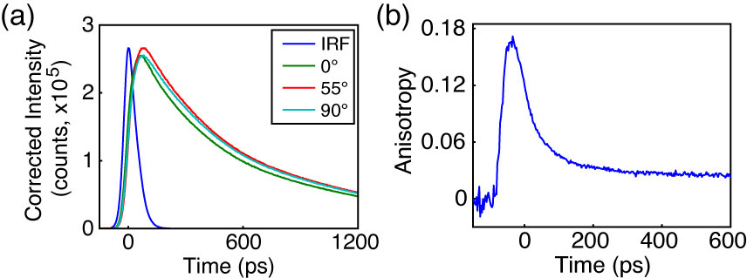

**Fig. 7.** Anisotropy data for PFBT in 40% THF. (a) Intensity decays collected at 0° (green), 55° (red), and 90° (cyan) polarizer orientations with sample IRF (blue). (b) Anisotropy decay *r*(*t*) constructed from intensity data in (a).

**Picosecond Fluorescence Anisotropy Decay (FAD).** Polarized intensity decays collected at 0°, 90°, and 55° relative to the vertically polarized excitation pulse [awk. properly scientific/standard phrasing?] were obtained via ~~reverse-mode~~ [unimportant detail discussed elsewhere] TCSPC (c.f. Fig 7a). The resulting polarized intensity decays were utilized to construct time-resolved anisotropy decays by the relation , where , , and G is a correction factor accounting for differences in detector sensitivity to vertically and horizontally polarized light (c.f. Fig 7b) [do we need the G stuff? I think it is more of an issue when a monochromator is used. In any case, such details might belong in “experimental” or the SI]. The process by which the anisotropy data is calculated from the fluorescence intensity decays at each polarizer orientation was adapted from a method by Fleming et al. and is described in detail in the Supporting Information.{Cross, 1984 #87}



[note: somewhere in the first para. or so of this subsection, you need to briefly explain qualitatively how anisotropy decay results can tell us something about homo transfer rates. Preferably in the intro sentence: it is better to motivate a section with an intro sentence or sentences that gives the reader some idea why you did the experiment, rather than just recite several bland textbook definitions (some are necessary, but don’t lead with them, and try to limit them).]

Despite the high signal levels (peak SNR ≥ 500:1) in the intensity decays of the MEH-PPV samples, only MEH-PPV in solution yielded a complete set of intensity decays that were usable for fitting analysis (*r*0 = 0.07 c = 290 ps).[did you define tau_c yet? You probably also need to give an expression.] This is likely due to limitations in the time-resolution of our instrument, as well as the low anisotropy signal relative to the overall intensity decay trace (c.f. Fig 7a) [too many words to say that due to the short lifetime and rapid anisotropy decay for MEHPPV, we only got one data point. tighten it up.]. The correlation time calculated from the fitting analysis does approximately match typical correlation times reported previously for MEH-PPV.{Nguyen, 1999 #96;Bjorklund, 2001 #97} The representative intensity decays, and constructed anisotropy decay for moderately swelled PFBT CPNs are given in Fig. 7. For 40%, 60%, 95% and 100% THF, the *r*0 values calculated from the fitting analysis procedure are 0.18, 0.08, 0.07 and 0.09, and the phenomenological correlation times (c), are 21 ps, 450 ps, 910 ps, and 920 ps, respectively. Direct reconvolution fitting of the anisotropy decay in Fig 7b to a single exponential with a constant offset yields c of 20 ps with an offset of 0.03. The increasing correlation times indicate that anisotropy decays more slowly as THF concentration increases. This is expected due to a reduction in the rate of exciton energy transfer as the equilibrium interchromophore distance increases due to swelling. The low (~2x to ~50x lower than the theoretical maximum of 0.4) limiting anisotropy values obtained from fitting analysis for both polymers suggest that either the transition dipoles are not initially well-aligned, or that the time window we are able to observe is after some depolarization has already occurred. From the FAD fitting analysis, it is possible to calculate [estimate? obtain?] the multiple energy transfer rate constant ~~by~~ *~~k~~~~et~~* ~~= ~~~~c~~~~-1~~.[there are probably some assumptions or hypotheses in there. Discuss those rather than dwelling on trivial math or procedural issues--yes, everyone knows rate constants are reciprocals of time constants.] For PFBT CPNs in 40% THF (given that a more significant anisotropy decay is observed for this sample), c from the fitting analysis is 21 ps, which corresponds to a multiple energy transfer rate constant of 4.81010 s-1. Compared to the free PFBT polymer in THF, with c ~900 ps, this corresponds to *ket* = 1.1109 s-1, which suggests that multiple energy transfer between equivalent chromophores is amplified [in other papers and maybe in this one as well, we say that multiple energy transfer to acceptors is an amplification process (due to “cascading” or “harvesting”, kind of like in a PMT) so to refer to an increase in multiple energy transfer as amplification sounds odd/redundant, like “amplified amplification”] in the aggregated state, even with moderate swelling.[not sure what you are getting at here]



In order to provide a rough [need something to clarify that this is model results, and we are trying to get them into a form we can use to compare to the experimental ket] estimate of the correlation times for the CPNs in water,[this phrase is ambig--sounds like you are discussing reduction of experimental data] the approximate c was calculated from the model energy transfer probabilities by . After Taylor expansion of the exponential term, the multiple energy transfer rate constant can be approximated as .[too wordy/detailed--cut the Taylor stuff and give the last expression.] The results of these calculations yield rate constants of 2.01011 s-1 for MEH-PPV CPNs and 1.11010 s-1 for PFBT CPNs. Comparing to *ket* for the polymers in good solvent yields 3.4109 s‑1 for MEH-PPV and 1.1109 s-1 for PFBT.[“comparing” and “yields” are ambiguous here. Also, are these theory results or ket from experiment?] This indicates that the energy transfer rate to six nearest neighbors (for the nanoparticles) is between ~10x and ~60x faster than the energy transfer rate to two nearest neighbors (for a linear polymer in solution).



Examination of the calculated rate constants from the model in conjunction with the FAD fitting analysis results for both polymers, further speculation could be made that many of the observed photophysics for both polymers are dictacted [sp] by the multiple energy transfer rates. The results for MEH-PPV indicate that the multiple energy transfer rate of MEH-PPV is significantly higher as compared to PFBT, which would make it well-suited for applications requiring greater exciton mobility. In addition, this could lead to difficulty in accurate determination of the intrinsic exciton diffusion length for polymers such as this, since exciton motion is limited by the defect concentration,[it’s not really the concentration per se that does the limiting, though clearly it is an important factor] which leads to the exciton diffusion length effectively being defined by the distance between quenchers.[I sense some redundancy here]

Similarly, the multiple energy transfer rates could provide some explanation for the significantly poorer quantum yield of MEH-PPV as compared to PFBT, which would make PFBT more useful for applications requiring a higher luminescence yield. Given that the model results yield approximately the same number of quenchers per unit volume of polymer, it follows that if exciton transport is faster, then excitons would be more efficiently funneled to defect sites, reducing the number of emission events. Thus, even though similar behavior is exhibited with regard to quenching efficiency as we move from [awk?] a 3D particle to isolated 1D chains through swelling for both polymers, we still see large differences in fluorescence lifetime and quantum yield, due to significant differences in exciton mobility.

**CONCLUSION**

Steady-state and time-resolved fluorescence spectroscopic methods, in conjunction with a discrete lattice model were utilized to assess the effect of solvent-induced swelling on the steady-state spectra, exciton decay rates, and multiple energy transfer rates in conjugated polymer nanoparticles. For both polymers, the fluorescence quantum yield increases with increasing THF concentration, reproducing the fluorescence quantum yield corresponding to the free polymer at 95% THF. Analysis of the fluorescence spectra of MEH-PPV exhibits a significant blue shifted component to the spectra as THF concentration increases, which provides evidence of dissociation of the nanoparticle into free polymer, over the range of 40-80% THF. A multiple energy transfer model incorporating quenching by defects yielded good agreement to experimental quenching efficiency and TCSPC results at low to moderate THF concentrations. The model results yielded energy transfer rate constants of 2.01011 s-1 for MEH-PPV CPNs and 1.11010 s-1 for PFBT CPNs, and FAD fitting analysis yielded *ket* = 4.81010 s-1 for moderately swelled PFBT CPNs, which are 10-60 times higher than the values of *ket* obtained for the corresponding polymers in THF. Calculations assessing quenching efficiency for an ensemble of isolated 1D chains compared to a 3D nanoparticle yield nearly an order of magnitude difference in quenching, which indicates that exciton transport to quenchers is reduced significantly in 1D compared to 3D, resulting from the reduced number of nearest neighbor chromophores in 1D. The increased energy transfer rates in the nanoparticle state have meaningful implications for imaging and device applications, and these results elucidate an apparent tradeoff between exciton mobility and luminescence yield. The results are consistent with an effective chromophore diameter of ~1 nm and an energy transfer time of ~5 ps to ~90 ps between neighboring close-packed chromophores.



**ACKNOWLEDGMENTS**

We acknowledge financial support from the NSF under Grant No. CHE-1058885.

**REFERENCES**

**(1) Dennler, G., and Sariciftci, N. S. Flexible Conjugated Polymer-Based Plastic Solar Cells: From Basics to Applications. *Proc. IEEE* 2005, *93*, 1429-1439.**

**(2) Yim, K. H., Zheng, Z., Liang, Z., Friend, R. H., Huck, W. T. S., and Kim, J. S. Efficient Conjugated-Polymer Optoelectronic Devices Fabricated by Thin-Film Transfer-Printing Technique. *Adv. Funct. Mater.* 2008, *18*, 1012-1019.**